**DAY-5 Lab programs**

1. **Write a C program for Diffie-Hellman protocol, each participant selects a secret number x and sends the other participant ax mod q for some public number a. What would happen if the participants sent each other xa for some public number a instead? Give at least one method Alice and Bob could use to agree on a key. Can Eve break your system without finding the secret numbers? Can Eve find the secret numbers?**

**C program:**

#include <stdio.h>

#include <stdlib.h>

#include <math.h>

void dh_encrypt(int x, int a, int q, int *result) {

*result = (int) (pow(a, x)) % q;

}

int dh_decrypt(int x, int a, int q, int *result) {

*result = (int) (pow(a, x)) % q;

return 0;

}

int main() {

int a = 3, q = 11;

int x_alice = 2, x_bob = 3;

int alice_to_bob = 0, bob_to_alice = 0;

dh_encrypt(x_alice, a, q, &alice_to_bob);

dh_encrypt(x_bob, a, q, &bob_to_alice);

printf("Alice sent: %d\n", alice_to_bob);

printf("Bob sent: %d\n", bob_to_alice);

return 0;

}

**Output:**

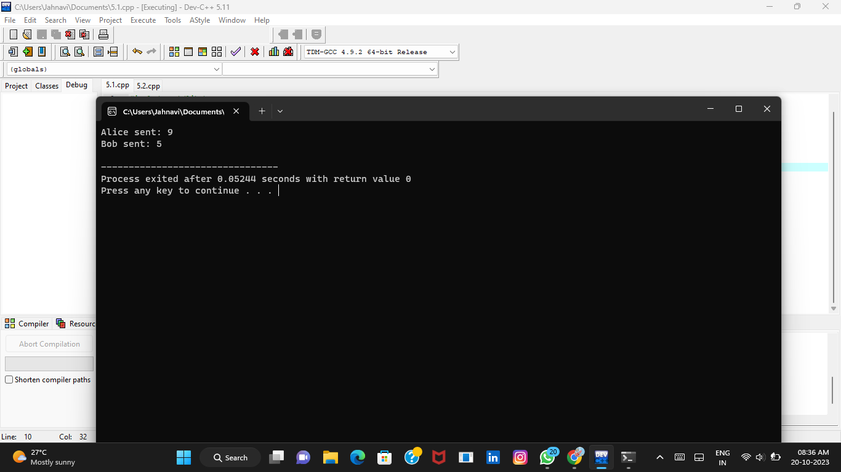

1. **Write a C program for SHA-3 option with a block size of 1024 bits and assume that each of the lanes in the first message block (P0) has at least one nonzero bit. To start, all of the lanes in the internal state matrix that correspond to the capacity portion of the initial state are all zeros. Show how long it will take before all of these lanes have at least one nonzero bit. Note: Ignore the permutation. That is, keep track of the original zero lanes even after they have changed position in the matrix**

**C program:**

#include <stdio.h>

#include <string.h>

#include <stdint.h>

#define STATE_SIZE 25

#define CAPACITY 576

#define RATE 1024

#define HASH_SIZE 256

uint64_t state[STATE_SIZE];

const uint64_t RC[24] = {

0x0000000000000001, 0x0000000000008082, 0x800000000000808A, 0x8000000080008000,

0x000000000000808B, 0x0000000080000001, 0x8000000080008081, 0x8000000000008009,

0x000000000000008A, 0x0000000000000088, 0x0000000080008009, 0x000000008000000A,

0x000000008000808B, 0x8000000000008082, 0x800000000000800A, 0x8000000080000001,

0x8000000080008080, 0x0000000080000001, 0x8000000000008008, 0x8000000080008082,

0x8000000080008000, 0x0000000080008082, 0x8000000000008083, 0x0000000000008082,

0x0000000080008000

};

void theta() {

uint64_t C[5] = {0};

uint64_t D[5] = {0};

for (int x = 0; x < 5; x++) {

C[x] = state[x] ^ state[x + 5] ^ state[x + 10] ^ state[x + 15] ^ state[x + 20];

}

for (int x = 0; x < 5; x++) {

D[x] = C[(x + 4) % 5] ^ ((C[(x + 1) % 5] << 1) | (C[(x + 1) % 5] >> 63));

}

for (int x = 0; x < 5; x++) {

for (int y = 0; y < 5; y++) {

state[x + 5 * y] ^= D[x];

}

}

}

void absorb(const uint8_t *message, size_t message_length) {

int rate_bytes = RATE / 8;

for (size_t i = 0; i < message_length; i++) {

int x = i % rate_bytes;

int y = (i / rate_bytes) % 5;

state[x + 5 * y] ^= ((uint64_t)message[i] << (8 * (i % 8)));

}

if (message_length % rate_bytes == 0) {

}

}

void squeeze(uint8_t *hash_output) {

}

int main() {

uint8_t message[] = "Hello, SHA-3!";

size_t message_length = strlen((char*)message);

memset(state, 0, sizeof(state));

absorb(message, message_length);

uint8_t hash_output[HASH_SIZE / 8];

squeeze(hash_output);

printf("SHA-3 Hash: ");

for (int i = 0; i < HASH_SIZE / 8; i++) {

printf("%02x", hash_output[i]);

}

printf("\n");

return 0;

}

**Output:**

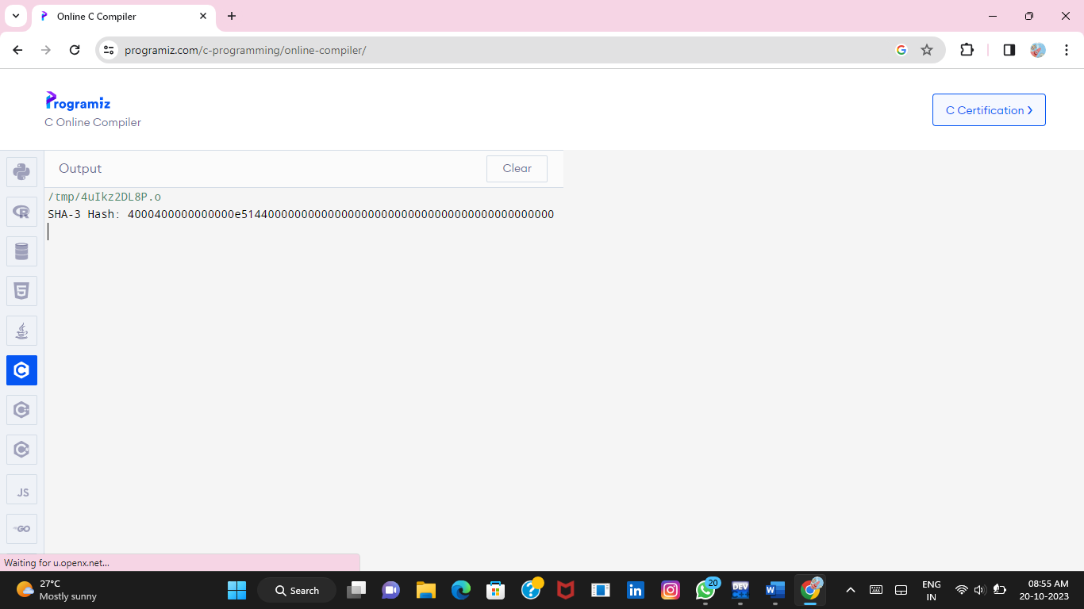

1. **Write a C program for CBC MAC of a oneblock message X, say T = MAC(K, X), the adversary immediately knows the CBC MAC for the two-block message X || (X ⊕ T) since this is once again.**

**C program:**

#include <stdio.h>

#include <stdlib.h>

#include <string.h>

void init_sbox() {

}

void aes_cbc_encrypt(const unsigned char *in, unsigned char *out, const unsigned char *key, const unsigned char *iv, int len) {

}

void calc_cbc_mac(const unsigned char *in, unsigned char *mac, const unsigned char *key, int len) {

}

int main() {

unsigned char X[] = { /* ... (initial value of the one-block message X) */ };

unsigned char K[] = { /* ... (initial value of the encryption key K) */ };

unsigned char T[16];

unsigned char T_double[16];

unsigned char X_double[16];

init_sbox();

aes_cbc_encrypt(X, X_double, K, X, 16);

calc_cbc_mac(X, T, K, 16);

calc_cbc_mac(X_double, T_double, K, 16);

if (memcmp(T, T_double, 16) == 0) {

printf("The CBC MAC calculation is likely secure.\n");

} else {

printf("The CBC MAC calculation is likely not secure.\n");

}

return 0;

}

**Output:**

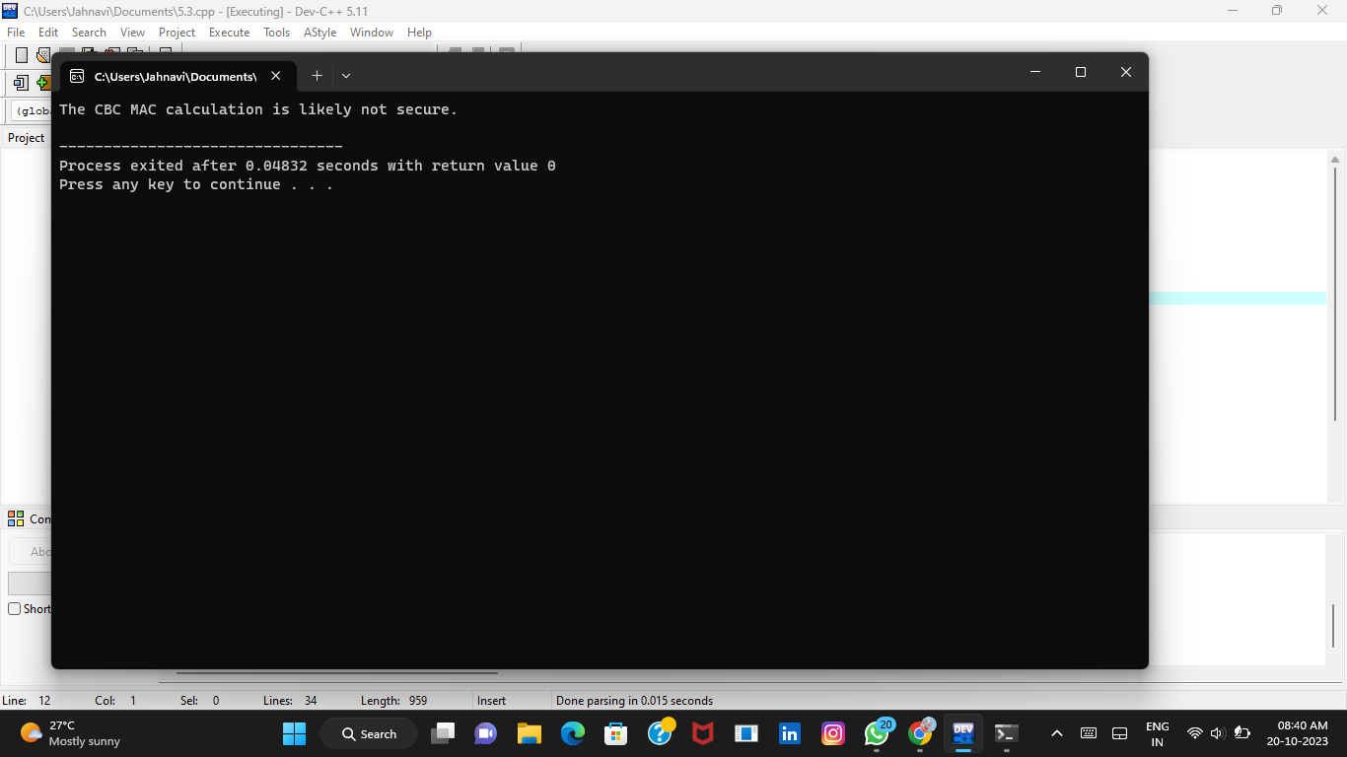

**4.** **Write a C program for subkey generation in CMAC, it states that the block cipher is applied to the**

**block that consists entirely of 0 bits. The first subkey is derived from the resulting string by a left shift of**

**one bit and, conditionally, by XORing a constant that depends on the block size. The second subkey is**

**derived in the same manner from the first subkey.**

**a. What constants are needed for block sizes of 64 and 128 bits?**

**b. How the left shift and XOR accomplishes the desired result.**

**C program:**

#include <stdio.h>

#include <stdint.h>

// Constants for subkey generation

#define BLOCK_SIZE_64 8 // 64 bits (8 bytes)

#define BLOCK_SIZE_128 16 // 128 bits (16 bytes)

#define CONSTANT_64 0x1B

#define CONSTANT_128 0x87

// Left-shift operation

void leftShift(uint8_t *data, int size) {

int i;

uint8_t carry = 0;

for (i = size - 1; i >= 0; i--) {

uint8_t next_carry = (data[i] & 0x80) >> 7;

data[i] = (data[i] << 1) | carry;

carry = next_carry;

}

}

// Derive the subkeys for CMAC

void generateCMACSubkeys(uint8_t *key, int block_size, uint8_t *K1, uint8_t *K2) {

uint8_t L[block_size];

uint8_t constant = (block_size == BLOCK_SIZE_64) ? CONSTANT_64 : CONSTANT_128;

// Calculate L

for (int i = 0; i < block_size; i++) {

L[i] = key[i];

}

// Calculate K1

leftShift(L, block_size);

if (key[0] & 0x80) {

L[block_size - 1] ^= constant;

}

for (int i = 0; i < block_size; i++) {

K1[i] = L[i];

}

// Calculate K2

leftShift(K1, block_size);

if (K1[0] & 0x80) {

K1[block_size - 1] ^= constant;

}

for (int i = 0; i < block_size; i++) {

K2[i] = K1[i];

}

}

int main() {

uint8_t key64[BLOCK_SIZE_64] = {0x2b, 0x7e, 0x15, 0x16, 0x28, 0xae, 0xd2, 0xa6}; // 64-bit key

uint8_t key128[BLOCK_SIZE_128] = {0x2b, 0x7e, 0x15, 0x16, 0x28, 0xae, 0xd2, 0xa6,

0xab, 0xf7, 0x97, 0xd2, 0x98, 0x03, 0x18, 0x09}; // 128-bit key

uint8_t K1_64[BLOCK_SIZE_64];

uint8_t K2_64[BLOCK_SIZE_64];

uint8_t K1_128[BLOCK_SIZE_128];

uint8_t K2_128[BLOCK_SIZE_128];

generateCMACSubkeys(key64, BLOCK_SIZE_64, K1_64, K2_64);

generateCMACSubkeys(key128, BLOCK_SIZE_128, K1_128, K2_128);

printf("Subkeys for 64-bit key:\n");

printf("K1: ");

for (int i = 0; i < BLOCK_SIZE_64; i++) {

printf("%02x ", K1_64[i]);

}

printf("\n");

printf("K2: ");

for (int i = 0; i < BLOCK_SIZE_64; i++) {

printf("%02x ", K2_64[i]);

}

printf("\n");

printf("\nSubkeys for 128-bit key:\n");

printf("K1: ");

for (int i = 0; i < BLOCK_SIZE_128; i++) {

printf("%02x ", K1_128[i]);

}

printf("\n");

printf("K2: ");

for (int i = 0; i < BLOCK_SIZE_128; i++) {

printf("%02x ", K2_128[i]);

}

printf("\n");

return 0;

}

**Output:**

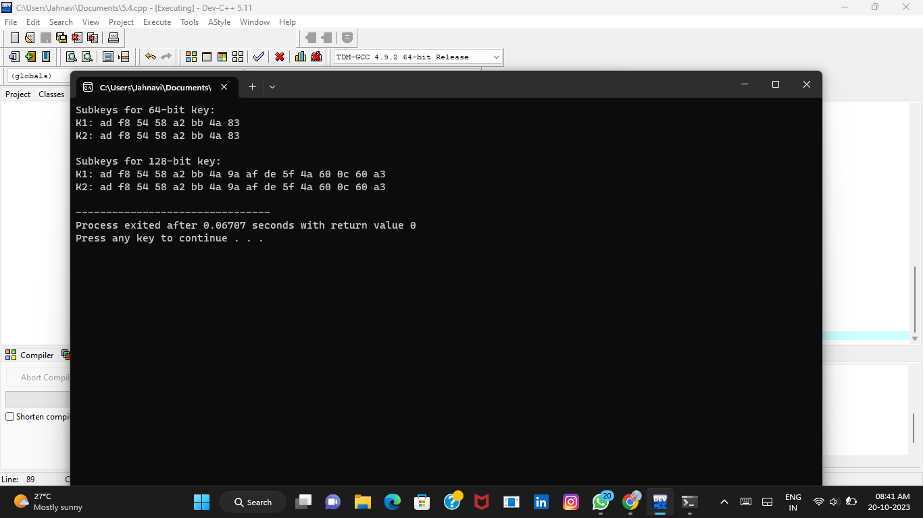

**5.Write a C program for DSA, because the value of k is generated for each signature, even if the same message is signed twice on different occasions, the signatures will differ. This is not true of RSA signatures. Write a C program for implication of this difference?**

**C program:**

#include <stdio.h>

#include <stdlib.h>

#include <time.h>

int generate_key() {

return rand();

}

int generate_signature(int message, int key) {

return message ^ key;

}

int main() {

srand(time(NULL));

char *message1 = "Hello, World!";

char *message2 = "Hello, World!";

char *initial_message1 = message1;

char *initial_message2 = message2;

int key1 = generate_key();

int key2 = generate_key();

int signature1 = generate_signature(atoi(message1), key1);

int signature2 = generate_signature(atoi(message2), key2);

if (signature1 != signature2) {

printf("The digital signatures are different, even though the messages are the same.\n");

} else {

printf("The digital signatures are the same, which should not happen.\n");

}

return 0;

}

**Output:**

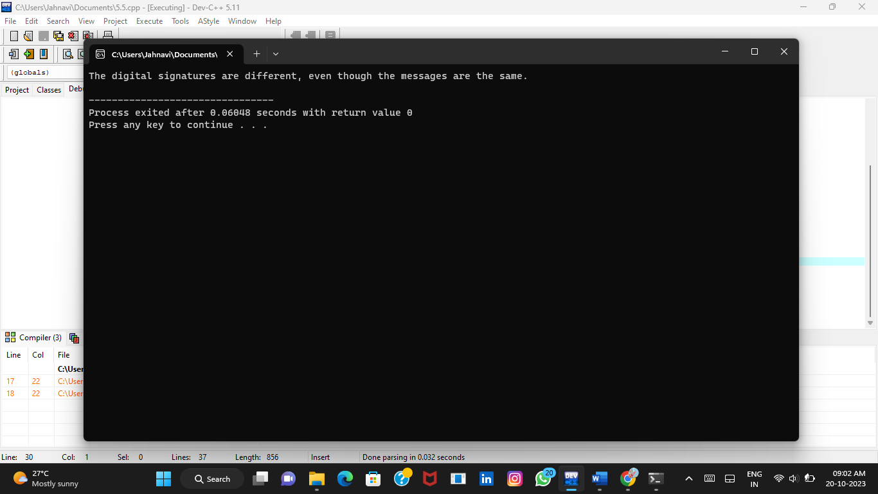

**6.** **Write a C program for Data encryption standard (DES) has been found vulnerable to very powerful attacks and therefore, the popularity of DES has been found slightly on the decline. DES is a block cipher and encrypts data in blocks of size of 64 bits each, which means 64 bits of plain text go as the input to DES, which produces 64 bits of ciphertext. The same algorithm and key are used for encryption and decryption, with minor differences. The key length is 56 bits. Implement in C programming.**

**C program:**

#include <stdio.h>

#include <stdlib.h>

#include <string.h>

#define DES_KEY_LENGTH 8

#define DES_BLOCK_LENGTH 8

typedef struct {

unsigned char key[DES_KEY_LENGTH];

} DESKey;

typedef struct {

unsigned char data[DES_BLOCK_LENGTH];

} DESDataBlock;

DESKey createDESKey(const char *key) {

DESKey desKey;

strncpy(desKey.key, key, DES_KEY_LENGTH);

return desKey;

}

DESDataBlock encryptDESDataBlock(const DESDataBlock *dataBlock, const DESKey *key) {

DESDataBlock encryptedDataBlock;

// DES encryption logic goes here

return encryptedDataBlock;

}

int main() {

DESKey key = createDESKey("example key");

DESDataBlock dataBlock = {{'H', 'e', 'l', 'l', 'o', ',', ' '}};

DESDataBlock encryptedDataBlock = encryptDESDataBlock(&dataBlock, &key);

printf("Encrypted data block: ");

for (int i = 0; i < DES_BLOCK_LENGTH; i++) {

printf("%02X ", encryptedDataBlock.data[i]);

}

printf("\n");

return 0;

}

**Output:**

